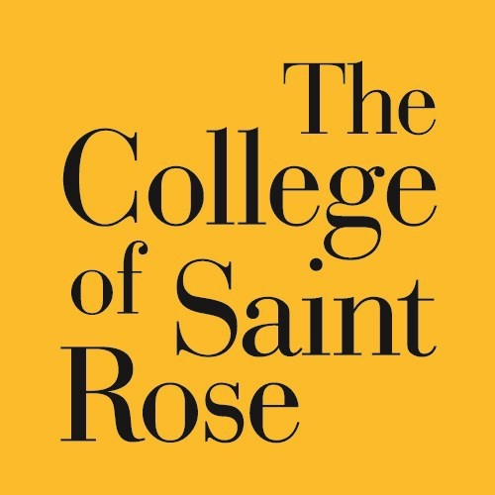
PARENT LOAN FOR UNDERGRADUATE STUDENTS (PLUS) APPLICATION
INSTRUCTIONS FOR APPLYING FOR A 2024-2025 PARENT PLUS LOAN
- Parent and Student must complete the 2024-2025 FAFSA at www.studentaid.gov
- Parent must apply for a PLUS Loan at www.studentaid.gov
-Go to “Loans and Grants”, then “I am the Parent of a Student”
-Parent will need to log in with their FAFSA ID & Pin
-Complete the credit check steps and submit (approval/denial of credit is immediate)
IF APPROVED continue to the next steps:
- Parent must complete the PLUS Master Promissory Note (MPN) at www.studentaid.gov
-Click the “Loans and Grants”, then “I’m a Parent of an Undergraduate Student”
-Complete required steps
- Complete this form and return it to : The College of Saint Rose, Attention: Office for Financial Aid, 432 Western Avenue, Albany, NY, 12203 or fax to: (518) 454-2109, or scan/email to: finaid@strose.edu
- The PLUS Loan interest rate is fixed at 8.05%, with a 4.228% origination fee
- Generally, repayment of a PLUS Loan begins 60 days after the final loan disbursement for the academic year
STUDENT INFORMATION
Student Name: _____________________Student ID#: _____________________
PARENT INFORMATION
Parent Name (one parent only):_ _______________________
Parent Date of Birth: Parent SSN:_____________________
Parent Street Address: ___ Parent City: State: Zip:______
Parent Phone #: Parent E-mail: _________________________
Parent Citizenship Status (Please Choose One): U.S. Citizen Eligible Non-Citizen
Parent Relationship to Student (Please Choose One): Biological Parent Adoptive Parent Eligible Stepparent
LOAN INFORMATION

Total PLUS Loan Amount Requested:_____________________(Whole dollars only, do not write “Maximum”)
The U.S. Department of Education will deduct 4.228% from the loan amount for an origination fee
Check here if you are requesting an ADDITIONAL parent PLUS loan amount.
Indicate the additional amount above.
Loan Period (Semester(s) in which requested amount is intended):
Summer 2024
PARENT BORROWER AUTHORIZATION
By signing below you certify that you (1) will use federal and/or state student financial aid only to pay the cost of attending an institution of higher education, (2) are not in default on a federal student loan or have made satisfactory arrangements to repay it, (3) do not owe money back on a federal student grant or have made satisfactory arrangements to repay it, (4) will notify your school if in default on a federal student loan, and (5) agree, if asked, to provide information that will verify the accuracy of your completed form. This information may include your U.S. or state income tax forms. Also, you certify that you understand that the Secretary of Education has the authority to verify information reported on this form with the Internal Revenue Service and other federal agencies.

*Electronic signatures will not be accepted*

Parent Signature: Date:

