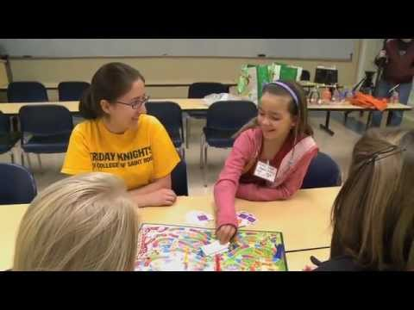

Have you heard about Friday Knights?
It is a recreation and family support program for children and adolescents with autism spectrum disorders (ASD) and their families.
It is held on the Saint Rose campus on Friday nights. This is our 15th year!!
It is a great opportunity to work with other College of Saint Rose undergraduate and graduate students to provide recreation for children and adolescents with autism spectrum disorders, their parents, and siblings.

Why do Friday Knights?
- It is a fun way to spend 5 of your Friday evenings.
- You get valuable experience working with kids with ASD.
- You provide service to the community. If you have a service requirement for a course, this can possibly meet that goal.
- It meets from 5:30-8:15 pm, so you can still go out afterwards!
- Do it with a friend and share the experience together!
- Current rates of autism spectrum disorders are 1 in 68. If you plan to teach, you will likely have a child with ASD in your classroom. You’re going to love the kids!!
If you would like to participate, please go the following link and complete the application on line. We are not accepting hard copy applications.
Please use this link to access the Fall 2018 application.
https://goo.gl/forms/sgRf2umLEPOUtJei1
Additional volunteer opportunities available through our spring semester swim program “Friday Fishes” or fall “Thursday Social Group” assistants.
Contact Dr. Susan DeLuke at fridayknights@strose.edu with any questions.
Program Dates for Fall 2018: 10/19, 11/2, 11/9, 11/16 and 11/30
Applications are due by September 24th at 3 p.m.
ALL NEW Volunteers attend one of the following mandatory meetings. Returning volunteers the last half hour of one training.
Wednesday, October 3rd 6:00-8:00 pm (location TBA) or
Tuesday, October 9th 2:25-4:25 pm (location TBA)

