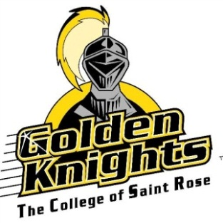

FALL 2017 SPEECH AND LANGUAGE GROUPS

Toddler Language Group (Little Explorers)
Wednesday and Friday: 9:00-10:00 a.m.
- This group is designed for 18-36-month-old children. It includes a language-rich curriculum focusing on developing and exploring the children’s expressive, receptive, and social language development with an emphasis on each child’s individual needs.

Preschool Speech and Language Group (Young Navigators)
Wednesday and Friday: 10:15-11:15 a.m.
- This group is designed for 3-5-year-old children. It includes a language-rich curriculum focusing on developing and navigating the children’s social language, literacy skills, speech sound development, and language development with an emphasis on each child’s individual needs.

These groups are supervised by a licensed speech-language pathologist. Within the group setting, individual therapy is provided for each child by graduate student clinicians.

Location
The College of Saint Rose
Literacy House, 441 Western Avenue
Albany, NY 12203

Cost: $40 per week for two, one-hour group sessions; payable weekly

Please call with any questions or additional information:
Colleen Fluman, M.Ed., CCC-SLP
(518) 337-4346
flumanc@strose.edu

