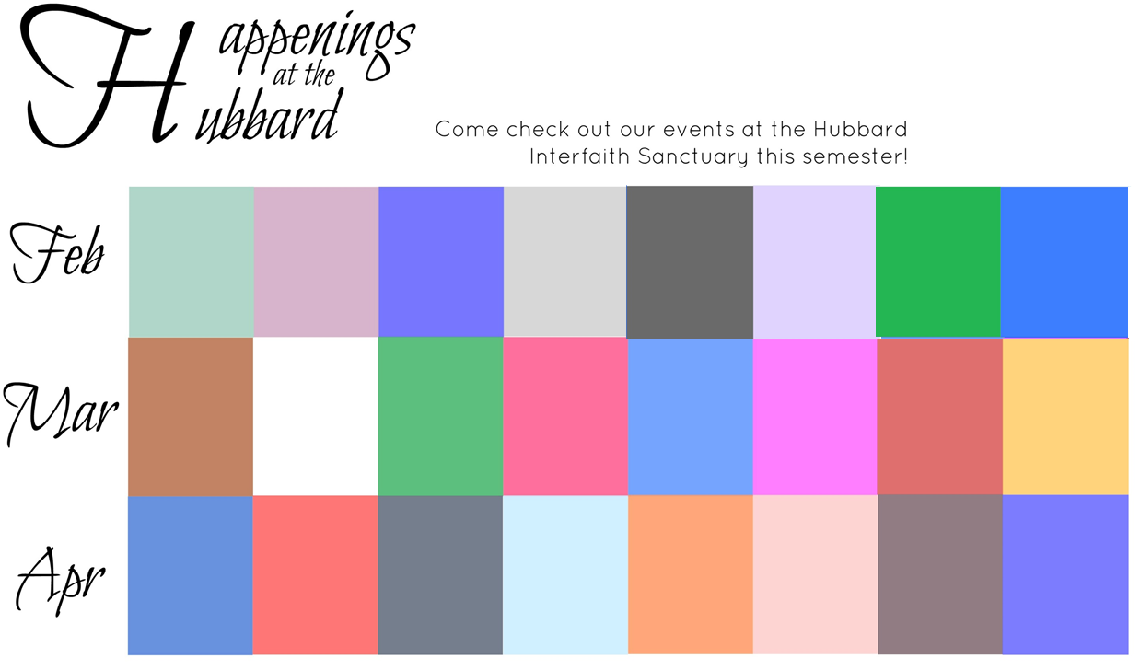

23

10

21

**Gospel Choir Night**

Music that inspires and celebrates

7-9:30pm

Bryan Stevenson Making Black/All Lives Matter in the Justice System

7:30 pm

Questions about the happenings? Email Joan Horgan at horganj@strose.edu

Coming Soon…

GUNS –

Where are the sane choices in the debate?

Date/Time/Place TBD

**In Feb. & March The Labyrinth**

Come participate in a meditative walk in our Sanctuary.

Feb. 23 & Mar. 22

Stop by b/w

9:00 am – 6:00 pm

*The Letters*

Mother Teresa’s

Challenging

Journey of Faith

7:00 pm

Before the end of the semester

This semester!

Capital Region Women of Color-

Champions for Justice

6:00 pm

Touhey Forum

Islamophobia

Discussion – What makes for peace?

April 5 or 12 - TBD

21

*A Place at the Table*

*Chldren and Hunger*  in America

7:30 pm

“Fill Their Bowls”

Mac & Cheese Cook-Off

EAC MAIN LOUNGE

4:30 pm

31

“Ladies Day Out”

A series of films about women leading the way

Stop by between

11 am & 4 pm

LGBTQ Community

How do you find a safe spiritual home?

TBD

**Refugees, Immigrants,** **Asylum Seekers:** What Now?

TBD

Autism -

In My Eyes

Albertus 211

7:30pm

17

“2 Women’s Stories”

Anti-Human Trafficking Discussion

6:00 pm

31

18

Super StRose Sweep

@ the International Price Chopper on Central – 8pm

19-20

Lenten Retreat

Skye Farm

Contact horganj@strose.edu for more details!

Better Together

Interfaith Student Group

8:00 pm

EarthPeace

Eco-ministry Gathering

7:00 pm

Every Monday this semester:

Every Tuesday this semester:

*Guided Meditation*

8:30 pm

*Yoga*

7:00 pm

5

*Radical Grace*

Nuns take to a school bus to fight for social justice

7:00pm

Spoken Word Artist - Carlos Andres Gomez

8pm @ St. Joe’s

18

15

14

1

Ash Wednesday Services

12:00 pm &

9:30 pm

10